MACH4METAL

metalworking machinery
Transito 21,
6909 DA BABBERICH
Netherlands
Tel. +31 (0)316 – 247123
Fax. +31 (0)316 - 247956
info@mach4metal.com
www.mach4metal.com

Bank No : 66.52.13.883
IBAN : NL33 INGB 0665 2138 83
BIC : INGBNL2A

DECKEL MAHO DMC 63 V
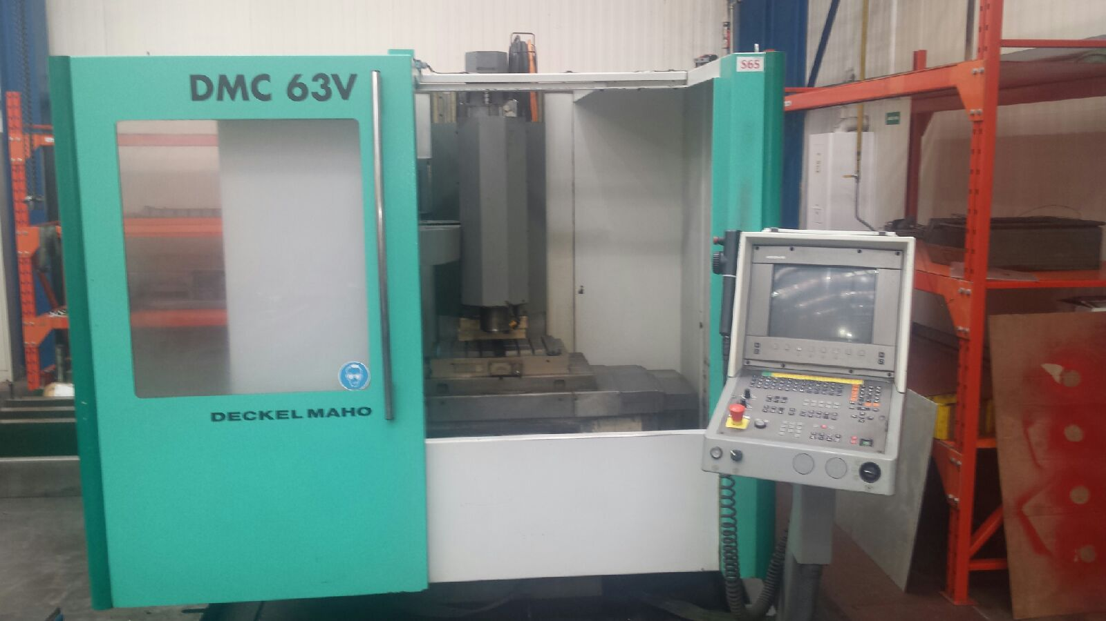
- Make : DMU Germany
- Type : DMC 63 V
- Mach.No : 1106 …. …
- Age : 2000

- Capacity – movements
- X - Travel : 630
- Y - Travel : 500
- Z - travel : 500
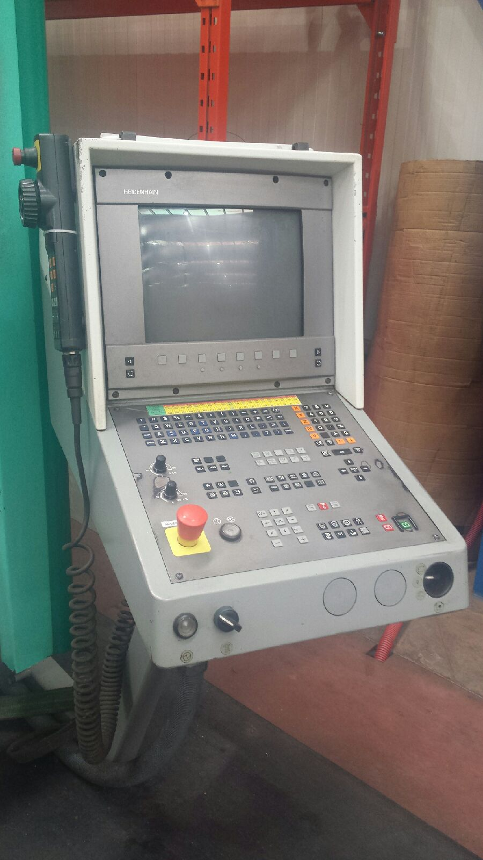

- Table length : 800
- Table width : 500

- Spindle : BT 40
- Speeds : 8.000 Rpm
- Power : 10kW 100 %

- Rapid all 3 axis : 30.000 mm/min
- Feed all 3 axis : 10.000 mm/min

- ATC Tool changer : 24 positions
- Chip conveyor ?
- HeidenHain TNC 430 in 3 axis
- Power hours 38.000

- Dimensions
- Length : 3.180
- Width : 3.005
- Height : 2.630
- Weight : 4.500

Please Note: The above information has been obtained to the best of our ability and belief from, and from the manufacturers where possible. It is given in good faith, but its accuracy can not be guaranteed. Accordingly, it will not form a representation or constitute contractual terms. We advise you to check any vital details!

